Q) Install & Configure Wordpress / Magento / Drupal / php / website with nginx proxy.

=> Wordpress installation:

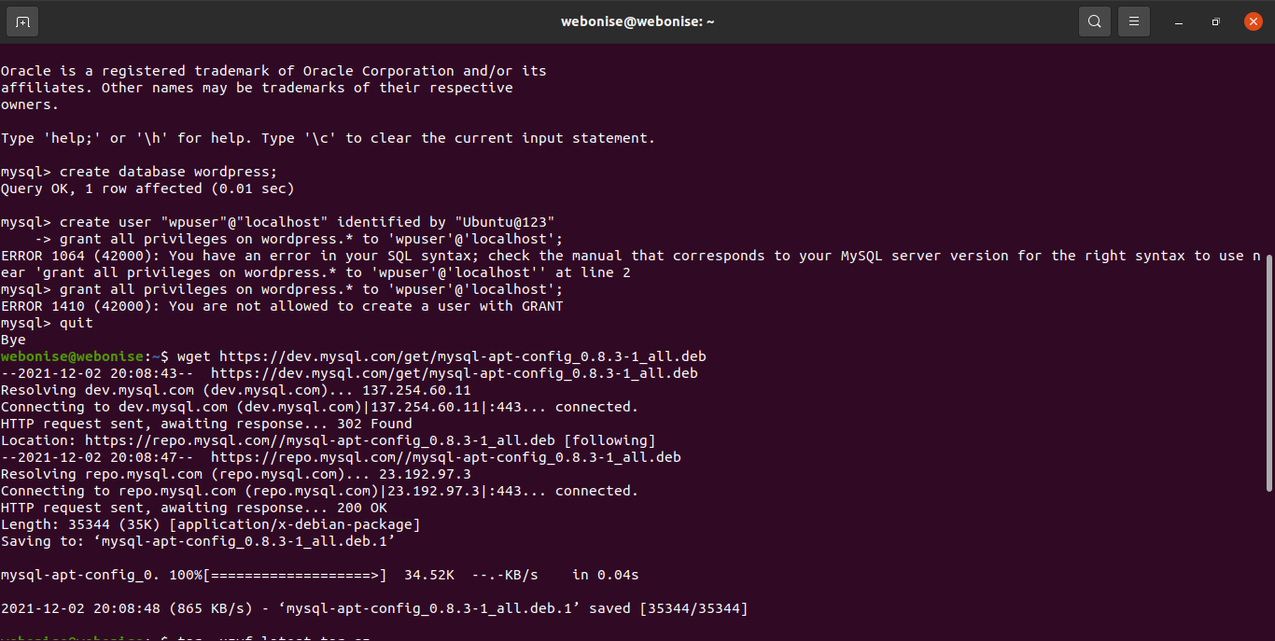

=> nginx installed :

